BANK NOTE FORGERY DETECTION REPORT
Author: Astolfo Romero

- INTRODUCTION
Forgery of Bank notes is a recurring problem nowadays. Even with the inclusion of watermarks, UV patterns or other security measures to try and prevent forgery, fake notes keep being circulated in the market made with improved techniques to defeat all those security measures. This situation results in a constant battle of developing security measures and the forgers creating new techniques to circumvent them.
Given this, a different approach is necessary. A technique exists called Wavelet Image Transform, that allows to extract features from an image in a way that is harder to predict its results and as such, harder to manipulate to obtain a desired result. We can use this technique to obtain common features of genuine bank notes and compare them to forged notes.
The following Data Science project has the objective of creating a program that distinguishes between forged and genuine bank notes, based on the features extracted from their Wavelet Image Transform using the K-Means algorithm.
- THE DATASET
To train the algorithm, a simplified version of the Bank Note Authentication dataset was employed, which contains the features V1, variance of the wavelet, and V2, skewness of the wavelet. Additionally, the dataset contains 1372 data points, which provided enough data to properly train the algorithm.
Subsequent analysis of the data, via the histogram of its features (Fig 1), shows that both features have a roughly Normal distribution, which means the values are dispersed throughout its range of values and for our purposes means that it represents notes in various condition of deterioration and in different positions, which makes it suitable for training purposes.
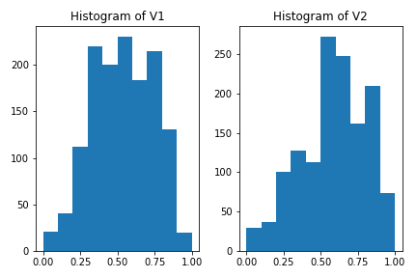

Fig 1. Histogram of features V1 and V2

- TRAINING OF THE ALGORITHM
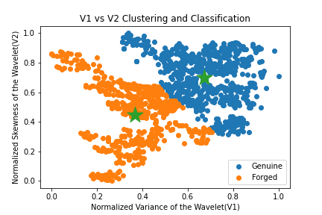
To achieve better results, the data was normalized between values of 0 and 1, so that the difference in range of values between features would not affect the performance of the algorithm. After normalizing the data, the K-Means algorithm was run multiple times looking for two clusters, which would represent the categories of Genuine and Forged. After validating that the center of the cluster remained stable through multiple runs, a scatter plot containing the resulting labels and the clusters was produced (Fig 2)
Fig 2. Clustering and Labeling Result

- RESULTS
The classification of each note generated by the K-Means algorithm was cross checked with the original Bank Notes dataset, which has a Class column that indicates if the given note is Genuine or Forged, and as a result, an accuracy of 87.24% was calculated.
- CONCLUSION
Based on the results, we can affirm that the K-Means algorithm can reliably detect forged bank notes based on their Wavelet Image Transform, as long as its trained with a sufficiently big dataset, that has bank notes of different degrees of degradation and the resulting data is normalized.

Dua, D and Graff, C. (2019)
Dua, D and Graff, C. (2019)

